**Project Objective**

MARKETING CAMPAIGN ANALYSIS

NIKHIL .K. DAS

* **Utilization of Business Intelligence (BI) Tools:** Leverage Microsoft Power BI to analyze multi-channel marketing data, delivering a comprehensive evaluation of campaign performance and customer engagement.
* **Focus on Revenue and Cost Insights:** Emphasize the identification of key revenue-generating channels, cost optimization opportunities, and ROI trends to guide data-driven marketing decisions.
* **Creation of Comprehensive Dashboards:** Develop an interactive dashboard offering a 360° view of marketing performance, covering total revenue, cost, unique customers, impressions, and clicks across all channels.
* **Executive Summary and Key Performance Indicators (KPIs):** Curate essential KPIs such as Total Revenue (100.41M), Total Cost (50.14M), ROI by channel, and customer growth trends to provide stakeholders with a clear performance snapshot.
* **Channel-Wise Performance Tracking:** Enable granular insights into marketing channels such as Facebook Ads, Google Ads, SEO, Email, Affiliate, and Social Media, highlighting their contribution to revenue and engagement.
* **Customer Demographics & Behavior Analysis:** Provide visual insights into customer gender distribution, website visits, and growth trends over time to better understand the target audience.

DATA DICTIONARY

FACT TABLE:

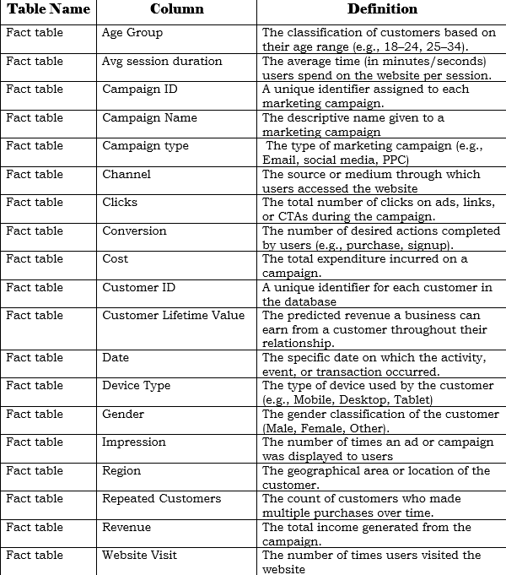

Customer Table:

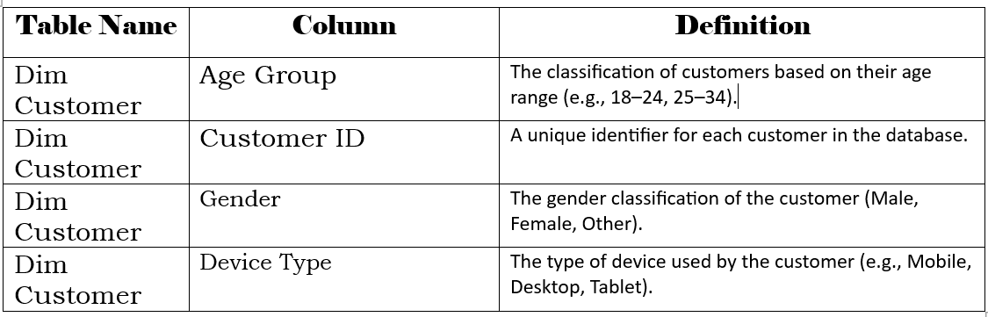

Date Table:

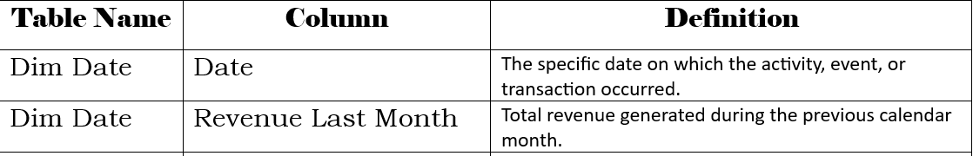

Campaign Table:

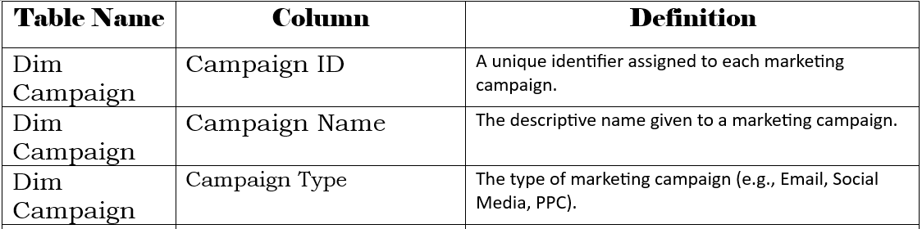

Project Overview: Marketing Campaign Analysis with Power BI

OVERVIEW:

The project aims to conduct a comprehensive analysis of one year’s worth of marketing and customer engagement data utilizing Power BI. The analysis will focus on presenting key performance trends and insights across campaigns, channels, and customer segments, aiding businesses in making data-driven decisions, optimizing marketing spend, and improving overall ROI.

HIGHLIGHTS:

* **Comprehensive Campaign Analysis:** Covers clicks, impressions, conversions, revenue, and cost to measure campaign success.
* **Channel & Device Segmentation:** Tracks performance across marketing channels and device types for better resource allocation.
* **Revenue Trends:** Highlights revenue generated month-over-month for identifying seasonal patterns.
* **Cost & ROI Optimization:** Compares campaign cost against generated revenue, helping businesses identify profitable and underperforming campaigns.
* **Customer Retention Metrics:** Tracks repeated customers and lifetime value to support loyalty program planning.

DASHBOARDS

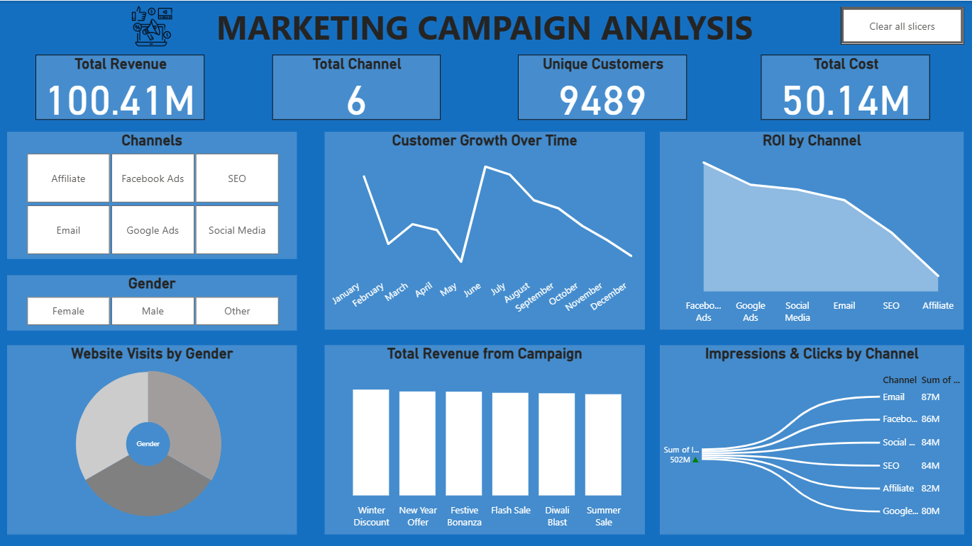

PROJECT CONCLUSION:

The project delivered a comprehensive analysis of marketing performance and customer engagement, leveraging Power BI for data visualization and insight generation. By integrating key metrics such as clicks, conversions, revenue, and cost, the analysis provided a clear understanding of campaign effectiveness and customer behaviour.

The outcomes of this project will support data-driven decision-making, enabling businesses to refine marketing strategies, allocate resources more efficiently, and maximize return on investment. This initiative sets a strong foundation for continuous performance monitoring and future growth optimization.